# Data Representation

Q1: Fill out the following table [6]

|  |  |  |
| --- | --- | --- |
| Decimal | Binary | Hexa- decimal |
| 48 |  |  |
|  | 01101101 |  |
|  |  | 2BE |

Q2: Convert the following [6]

|  |  |
| --- | --- |
| Text | 7 Byte Binary ASCII Code |
| NU-FAST |  |

Q3: Represent the following in 2s compliment [8]

|  |  |  |
| --- | --- | --- |
| Integer | 1 Byte representation | 2 Byte representation |
| -14 |  |  |
| 14 |  |  |
| 30 |  |  |
| -34 |  |  |

Q4: Represent the following in signed magnitude [4]

|  |  |
| --- | --- |
| Integer | 1 Byte representation |
| 55 |  |
| -55 |  |
| 31 |  |
| -31 |  |

Q5: What is the Maximum signed (sign magnitude) integer value that can be represented using 1 Byte? [2]

Q6: What is the Maximum unsigned integer value that can be represented using 2 Bytes? [2]

Q7: Fill the following for unsigned integers [6]

|  |  |  |
| --- | --- | --- |
| Integer | 1 Byte representation | 2 Byte representation |
| 196 |  |  |
| 55 |  |  |
| 100015 |  |  |

Q7: If you have an RGB image of size 300x300 then how much space (in Bytes) it would take in computer memory? [2]

# Week - Computer Organization and OS

1. What will be the speed of 2.5 GHz processor in term of fetch-decode execute cycle? [2]
2. What is the purpose of base register and bound register? [2]
3. Complete the process state diagram, given the states of the processes. [5]

Ready

Waiting

Running

Terminated

New

1. What is the difference between a process and a program? [2]
2. What is the purpose of context switching? [2]
3. What is the purpose of process control block? [2]
4. **Consider the set of 5 processes whose burst time are given below. Draw a Gantt chart to show turnaround time for RR CPU scheduling with time quantum of 2 units. Also fine the average turnaround time. [5]**

|  |  |
| --- | --- |
| Process Id | Service-Time |
| P1 | 6 |
| P2 | 5 |
| P3 | 2 |
| P4 | 3 |
| P5 | 7 |

1. Given the following memory map, fill the following [5+5]

|  |  |  |
| --- | --- | --- |
| Size | First Fit | Best Fit |
| 100KB |  |  |
| 500KB |  |  |
| 200KB |  |  |
| 300KB |  |  |
| 600KB |  |  |

|  |  |  |  |  |
| --- | --- | --- | --- | --- |
| Job1 | Job2 | Job3 | Job4 | Job5 |
| 212KB | 417KB | 112KB | 426KB | 55KB |

# Database

* + - 1. Some tables are given with queries, identify the changes and update tables/database.

# Networking

* + - 1. Add few questions

# CG

Differentiate between Vector and Bitmap graphics. [2]

Differentiate between DIP and CG [2]

# AI

1. Connect the table below [6]

* Knight’s Plight placement on the chess board
  + Planning
* Puzzle that involves calculation
  + Calculation, Computation, Reasoning
* spam mail filter
  + Unsupervised Learning
* Weather forecasting using previous year data
  + Supervised Learning
* Series Completion
  + Prediction
* Road Crossing
  + Rational Actions

|  |  |
| --- | --- |
| * Weather forecasting using previous year data | * + Planning |
| * Road Crossing | * + Calculation, Computation, Reasoning |
| * spam mail filter | * + Supervised Learning |
| * Series Completion | * + Unsupervised Learning |
| * Knight’s Plight placement on the chess board | * + Prediction |
| * Puzzle that involves calculation | * + Rational Actions |

# Math

Given the graph below, use method discussed in class (dijkstra’s algorithm) to find the shortest path from the top left corner vertex/node (v1) to the bottom right vertex/node (v6). Label the vertices/nodes accordingly. Give the length of the shortest path. [6+2]

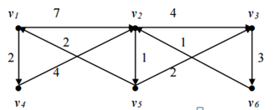

1. Create adjacency matrix for the following graph. Assume that each link has weight 1. [4]

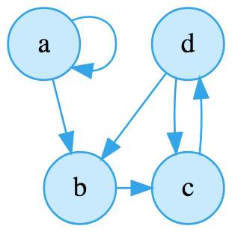

# DATA Science

1. Differentiate between supervised and unsupervised learning with an example. [1+1+1]

2. Differentiate between classification and regression with an example. [1+1+1]

# Internet

Create a simple html web page for the following specifications. [6+4]

1. A text “A Simple Web Page” as heading.
2. An image showing in the middle of the page.
3. A paragraph explaining the purpose of the page.
4. Set the color and font size of heading through by inline style.
5. Set the color of paragraph by inline style.
6. Set the margin of the link by inline style.